Chapter 17, Problem 66.

Determine the Fourier coefficients for the waveform in Fig. 17.48 using PSpice.

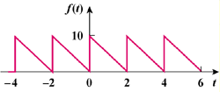

Figure 17.48
For Prob. 17.66.

